Entropy and Discrete Cosine Transform

1. Objectives:

Students will learn
- To learn the concept of 1-Dimension and 2-Dimensional Entropy.
- To understand the concept of Discrete Cosine Transform 1-Dimension and 2-Dimensional data (image) using the dctdemo.m.

2. Equipment: Laptop with MATLAB software and image processing toolbox installed.

3. Introduction
From the chapter on Information Theory, the average information content per symbol is known as ENTROPY. Entropy is a measure of unpredictability or a “surprise element”. Entropy in her abstract meaning is the randomness of information content.
Entropy is a measure of uncertainty. High entropy means the data has high variance and thus contains a lot of information and/or noise.
For instance, a constant function where y(x) = 3 for all x has no entropy because it is 100% predictable and it provides has little information. But if the function y(x) = ~3 has some entropy while y(x) = random number is very high entropy due to noise. Hence noise and information go hand in hand. Noise is the useless information contained in the data but they both add to the entropy.

In information theory an entropy encoding is a lossless data compression scheme that is independent of the specific characteristics of the medium. One of the main types of entropy coding creates and assigns a unique prefix-free code to each unique symbol that occurs in the input and Huffman coding is one of the entropy codings.

The formula for Entropy is given as below:

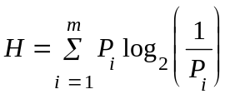

Where P_{i} is the occurrence probability of a given symbol S_{i}.

This is for the 1-dimensional array of symbols with its associated probability.

The information content of the symbol Si is defined as:

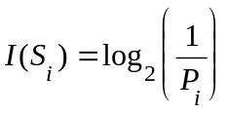

4. Lab Procedures
4.1 Computing entropy
4.1.1 Entropy for known probabilities
Assume p is a one-dimensional array that stores the probability of each symbol. E is the entropy. The sum of the probabilities of array must be 1. Create your Matlab program and name “Entropy_H.m”.

% Computing entropy for a 1-D array of probabilities
function H = Entropy_H(p)
i = length(p);
sum = 0;
for n = 1:i
H = sum + p(n)*log2(1/p(n));
end

>> p = [0.25 0.25 0.25 0.25];
>> H1 = Entropy_H(p) %Hint: H1= 2

What is the source entropy, H, minimum average number of bits per symbol?
What is the information content of each symbol?

>> p = [0.7 0.1 0.1 0.1]; %Hint: H1= 1.3568
>> H1 = Entropy_H(p)

What have you observed from the results?

4.1.2 Entropy for images – Histogram, Entropy and other Matlab Image Commands

We will use some simple Matlab command from the MATLAB Image Toolbox such as imread, imhist, imshow and entropy (for image). You can type help <command> where the command is any of the above. For example, help imread in the command section of the Matlab, will give you the explanation of the Matlab command plus how to use it. Two examples are given below.

imhist Display histogram of N-D image data

imhist(I) displays a histogram for the intensity image I whose number of bins are specified by the image type. If I is a grayscale image, imhist uses 256 bins as a default value. If I is a binary image, imhist uses only 2 bins. I can be 2-D, 3-D or N-D.

imhist (I,N) displays a histogram with N bins for the intensity image I above a grayscale colorbar of length N. If I is a binary image, then N can only be 2.

entropy - Entropy of intensity image

E = entropy(I) returns E, a scalar value representing the entropy of an intensity image. Entropy is a statistical measure of randomness that can be used to characterize the texture of the input image. Entropy is defined as -sum(p.*log2(p)) where p contains the histogram counts returned from IMHIST.

Image entropy is a quantity which is used to describe the amount of information which must be coded for by a compression algorithm. Low entropy images with very little contrast and large runs of pixels with the same values. An image that is perfectly flat will have an entropy of zero. Consequently, they can be compressed to a relatively small size. On the other hand, high entropy images great deal of contrast from one pixel to the next and consequently cannot be compressed as much as low entropy images.

In the case of an image, these states correspond to the grey levels which the individual pixels can adopt. For example, in an 8-bit pixel there are 256 such states. If all such states are equally occupied, as they are in the case of an image which has been perfectly histogram equalized, the spread of states is a maximum, as is the entropy of the image. On the other hand, if the image has been thresholded, so that only two states are occupied, the entropy is low. If all of the pixels have the same value, the entropy of the image is zero. We shall use some of the lab exercises as indicated below which use the following images.

Figure 1: Lena.tif Figure 2: Lapwing.jpg

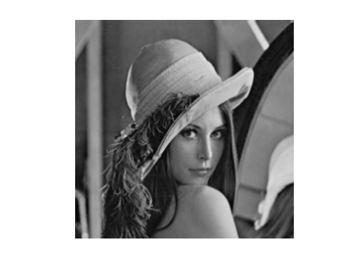

>> A = imread(‘lena.tif’);
>> imhist(A)
>> EA = entropy(A)
>> [m n] = size(A)
>> imageinfo(‘lena.tif’)

What do you observed after executing each Matlab’s command (imread, imhist, size, imageinfo) and explain the function of each command?

Repeat the above steps for the following image files, 'lapwing.jpg', ‘moon.jpg’ and ‘jupitor.jpg’.

What is the minimum bit rate to encode a pixel for image “lena”, “lapwing”, “moon” and “jupitor” without distortion?

>> aa=uint8(zeros(255,255)); %create a what by what matrix?
>> aa(:,:)=100; % if the value of 100 is changed to 0 or 255
>> imshow(aa)
>> entropy(aa)

Explain the value of aa obtained.

Try creating an image of RED colour below.

>> image=zeros(300,400,3);
>>image(:,:,1)=1; %Red (maximum value)
>>imshow(image)
>>entropy(image)

Is the entropy’s value zero? Why?

  - Discrete Cosine Transform

Discrete Cosine Transform, DCT is a technique applied to image pixels in spatial domain in order to transform them into a frequency domain as a sum of sinusoids of varying magnitudes and frequencies. The DCT is useful because most of the visually significant information especially for image is concentrated in just a few coefficients of the DCT. Hence, we can

DCT is a key compression technology for JPEG (Joint Photo-graphic Experts Group) for still-image compression and MPEG (Motion Picture Experts Group) for video compression with compression ratio more than 15.

4.2.1 One-Dimensional Discrete Cosine Transform, DCT

One-dimensional DCT is used in MP3.
- The DCT transforms the time domain signal to frequency domain coefficients.

- No complex number operations (Discrete Fourier Transform).

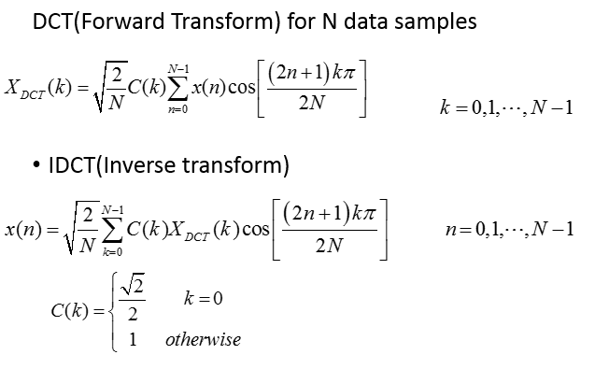

>> x=[10 8 10 12];

>> x1= dct(x)

>> x11=idct(x1)
You will notice that x11 has the same value as x. We have just perform DCT and inverse DCT on a 1-dimensional array of data.

A trivial example.

>> xx=10*ones(1,10);

>> xx1=dct(xx) %notice that the size of xx1 is the same as xx

>> size(xx)

>> size(xx1)

>> xxx1 = xx1(1) % just take the first coefficient as the rest are zeros.

>> yy = idct(xxx1,10) % value of yy is the same as xx

The above commands just perform a 2-dimension dct and inverse dct operation on the single dimensional array.

4.2.2 Compare Image Quality at Various Compression Levels using imwrite

>> I = imread('cameraman.tif');
>> imwrite(I,'compressedcameraman.jpg','jpg','quality',50) % Quality=50
>> imageinfo('cameraman.tif')
>> imageinfo ('compressedcameraman.jpg')
>> I1=imread('compressedcameraman.jpg');
>> subplot(1,2,1);imshow(I);subplot(1,2,2);imshow(I1);

In the above code, it uses a quality factor of 50. Quality is a number between 0 and 100; this parameter applies only if 'Compression' is 'jpeg'. Higher numbers mean higher quality (less image degradation due to compression), but the resulting file size is larger.

Use the imageinfo to get the file size of ‘cameraman.tif’ and ‘compressedcameraman.jpg’ for quality factor from 10 to 90 and compute the data compression ratio.

4.2.3 Two-Dimensional Discrete Cosine Transform, DCT

DCT decomposes a block of data. A typical block is 8x8 pixels. The DCT converts the block into a block of 64 coefficients. A coefficient is a number which describes the amount of a particular spatial frequency which is present. By performing DCT operation, the number of DCT coefficients are still the same.

Most images, many of the DCT coefficients have values quite close to zero; these coefficients can be discarded without seriously affecting the quality of the reconstructed image. This is where the reduction of the data happens. The DCT coefficients are then quantized, “coded”, and transmitted. At the JPEG receiver, the quantized DCT coefficients will be decoded, inverse two-dimensional DCT of each block is performed, and then the 8x8 blocks are reassembled back into a single image.

The two-dimensional DCT of an 8x8 pixels is defined as follows where M=N=8.
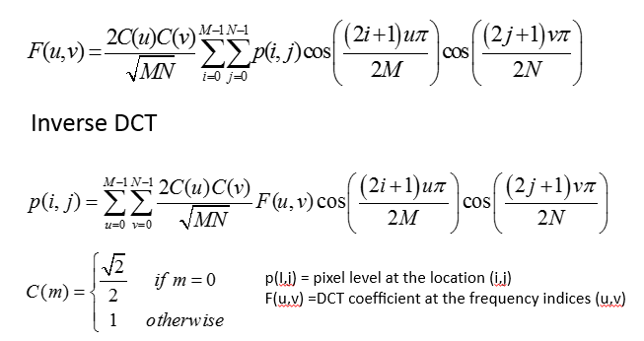

The values F(u,v) are called the DCT coefficients of p(i,j). i and j are indices of an 8x8 array of image samples, and u and v are indices into an 8x8 array of DCT coefficients.

- DC coefficient, F(0,0) - represents the average brightness of the block and so is the arithmetic mean of all the pixels or the DC component. For Matlab’s representation, matrix elements p(1,1) and F(1,1) correspond to the mathematical quantities p(0,0) and F(0,0), respectively.

- AC coefficients, each corresponding to the frequency components.

- From left to the right, the DCT coefficients represent increasing horizontal spatial frequency
- From top to bottom, the DCT coefficients represent increasing vertical spatial frequency.

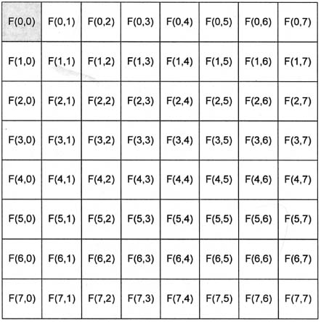

Table 1 : 64 DCT Coefficients’ Representation

Try out these codes that uses dct2(Matlab command for two-dimensional arrays).

>> clear
>> a=imread('lena.tif');
>> a1=dct2(a);
>> a1(1:10) % first 10 DCT coefficients
>> a11=idct2(a1); % uses all the coefficients
>> a11=uint8(a11);
>> imshow(a11) % original image

Try out the example code below computes the two-dimensional DCT of 8-by-8 blocks in the input image, discards (sets to zero) all but 7 of the 64 DCT coefficients in each block, and then reconstructs the image using the two-dimensional inverse DCT of each block. The transform matrix computation method is used.

>> I = imread ('cameraman.tif'); I = im2double (I);
>> T = dctmtx (8);
>> dct = @(block_struct) T * block_struct.data * T';
>> B = blockproc(I,[8 8], dct);
>> mask = [1 1 1 0 0 0 0 0;
1 1 0 0 0 0 0 0;
1 0 0 0 0 0 0 0;
0 0 0 0 0 0 0 0;
0 0 0 0 0 0 0 0;
0 0 0 0 0 0 0 0;
0 0 0 0 0 0 0 0;
0 0 0 0 0 0 0 0];

>> B1 = blockproc(B,[8 8],@(block_struct) mask .* block_struct.data);
>> invdct = @(block_struct) T' * block_struct.data * T;
>> I1 = blockproc(B1,[8 8],invdct);
>> subplot(1,2,1); imshow(I); subplot(1, 2,2); imshow(I1)

Record your result and comments.

You may like to mask different DCT AC coefficients, F(u,v) to see the impact on the reconstruction image.
MATLAB dctdemo: 2-D DCT image compression demo in Figure 4 below.

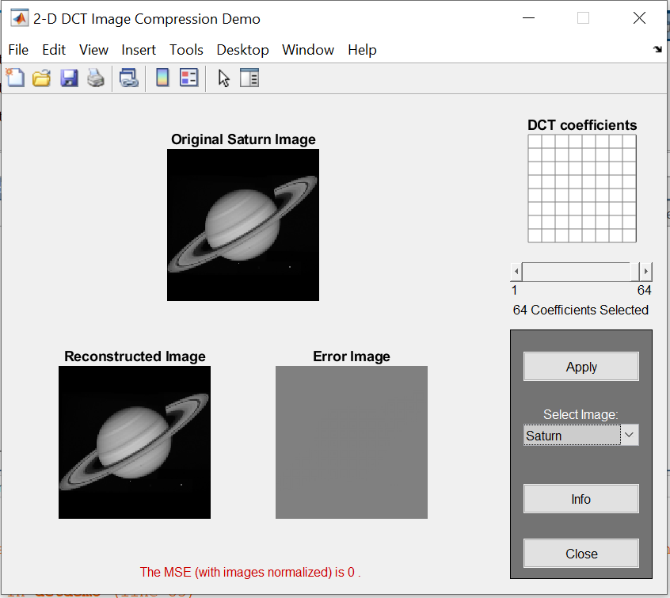

This demo lets you explore image compression using the 2-D discrete cosine transform (DCT). The original image is transformed in 8-by-8 blocks and then inverse transformed in 8-by-8 blocks to create the reconstructed image. The inverse DCT is performed using the subset of DCT coefficients that are shown in white. The error image (the difference between the original and reconstructed image) is also displayed.

The mean-square error (MSE) and the peak signal-to-noise ratio (PSNR) are used to compare image compression quality. The MSE represents the cumulative squared error between the compressed and the original image, whereas PSNR represents a measure of the peak error.

Use the slider to select a subset of the DCT coefficients and then press the "Apply" button to produce the corresponding reconstructed image. The DCT coefficients with small variance are discarded first, as they have the least effect on the reconstruction.

The Saturn image is courtesy of NASA. Select 32-coefficients and obtain the result. What is the MSE value?

What will the value of MSE if all the 64 coefficients are applied?

